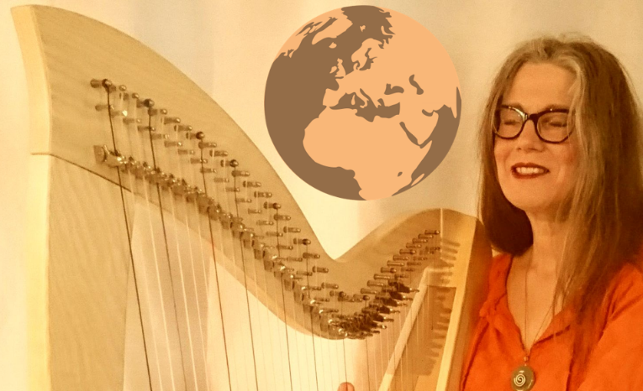
PRESS RELEASE
ROTTERDAM
Fri 2023 Aug 4
Citykerk
8pm CONCERT
9pm meet&greet

LONGER
Musical journey around the Earth with Marja de Jong
SHORTER
Musical journey around the Earth with Marja de Jong

Rotterdam – Friday evening, August 4, Master of Music Marja de Jong takes the STeiger audience to 10 different countries in one hour: depth and emotion with a cheerful note. 'Love for each other and for nature', resounds in Marja’s warm voice and heavenly harp playing.

The profit goes 50-50 to the Rotterdam Environmental Center and the Mensa Fund, due to 60 years Mensa NL. After the concert, CDs and sheet music can be obtained during the meet & greet.

Presale €12.50/€10.00/€7.50, at the venue €15.00 pp.
Citykerk Het STeiger, start 8pm, doors open 7:30.

Rotterdam – Friday evening, August 4, Master of Music Marja de Jong takes the STeiger audience to 10 different countries in one hour: depth and emotion with a cheerful note. The repertoire varies from Medieval to Folk and from Meditative to Swing. (Greece, Italy, Germany, Netherlands, England, Ireland, France, Spain, Hawaii and Cuba)

"Marja's warm voice reaches deep into the heart to awaken its primal wisdom," says city pastor Ad Boogaard. “As if an angel sings to us about the earth's treasures,” coach Tineke Willemsen adds.

'Love each other and nature,' Marja sings with heavenly harp playing. The core of the concert is Marja's composition 'Trilogy for the Earth': ignorant in lamentation 'Notre Terre', greener in ode 'Con los ojos verdes', and reverent in song of thanksgiving 'For the Beauty of the Earth'.

The profit goes 50-50 to the Rotterdam Environmental Center and the Mensa Fund, on the occasion of 60 years Mensa NL. This concert also serves the European meeting of Mensa, for which nearly 1000 members from 47 countries gather in the WTC, a 5-minute walk from the church.
After the concert, CDs and sheet music can be obtained during the meet & greet, while enjoying coffee, tea or juice.

Marja de Jong accompanies herself on among other a beautiful Rees Brilliant harp of almost 5 octaves, with a round, warm sound.

Presale €12.50/€10.00/€7.50, at the venue €15.00 pp.
Citykerk Het STeiger, start 8pm, doors open 7:30.

PRESS RELEASE
ROTTERDAM
Fri 2023 Aug 4
Citykerk
8pm CONCERT
9pm meet&greet

LONGER
Musical journey around the Earth with Marja de Jong
SHORTER
Musical journey around the Earth with Marja de Jong

Rotterdam – Friday evening, August 4, Master of Music Marja de Jong takes the STeiger audience to 10 different countries in one hour: depth and emotion with a cheerful note. 'Love for each other and for nature', resounds in Marja's warm voice and heavenly harp playing.

The profit goes 50-50 to the Rotterdam Environmental Center and the Mensa Fund, due to 60 years Mensa NL. After the concert, CDs and sheet music can be obtained during the meet & greet.

Presale €12.50/€10.00/€7.50, at the venue €15.00 pp.
Citykerk Het STeiger, start 8pm, doors open 7:30.

Rotterdam – Friday evening, August 4, Master of Music Marja de Jong takes the STeiger audience to 10 different countries in one hour: depth and emotion with a cheerful note. The repertoire varies from Medieval to Folk and from Meditative to Swing. (Greece, Italy, Germany, Netherlands, England, Ireland, France, Spain, Hawaii and Cuba)

"Marja's warm voice reaches deep into the heart to awaken its primal wisdom," says city pastor Ad Boogaard. "As if an angel sings to us about the earth's treasures," coach Tineke Willemsen adds.

'Love each other and nature,' Marja sings with heavenly harp playing. The core of the concert is Marja's composition 'Trilogy for the Earth': ignorant in lamentation 'Notre Terre', greener in ode 'Con los ojos verdes', and reverent in song of thanksgiving 'For the Beauty of the Earth'.

The profit goes 50-50 to the Rotterdam Environmental Center and the Mensa Fund, on the occasion of 60 years Mensa NL. This concert also serves the European meeting of Mensa, for which nearly 1000 members from 47 countries gather in the WTC, a 5-minute walk from the church.
After the concert, CDs and sheet music can be obtained during the meet & greet, while enjoying coffee, tea or juice.

Marja de Jong accompanies herself on among other a beautiful Rees Brilliant harp of almost 5 octaves, with a round, warm sound.

Presale €12.50/€10.00/€7.50, at the venue €15.00 pp.
Citykerk Het STeiger, start 8pm, doors open 7:30.

